# Abstract

The project is about a web application for collecting and visualize the information of cryptocurrency trading among different exchange websites. The application provides the visualization of real-time data based on the real trade information over the globe cryptocurrency market, users can use the visualized charts and tables to analyse the most important aspect of the cryptocurrency market performance. It will help the users make the investment decisions more efficiently and accurately.

# Introduction

A blockchain can be thought of as a distributed database across many nodes, the transactions can be reconciled and be recorded even when a few nodes on the network in various order. The blockchain technology has combined three features of the previous general and mature technologies, which are peer-to-peer networking, asymmetric cryptography, and cryptographic hashing. The first cryptocurrency, bitcoin, which is created based on these features by the pseudonymous Satoshi Nakamoto in 2009.

Token deals (likewise is called ICO) have stood out as truly newsworthy this year as a feature of enormous cost increments in the digital currency space. They convey a decentralised type of crowdfunding to the blockchain which means that it will not be controlled by an outsider, which is like the business model of Kickstarter but without the centralised manager. The prices of well-known digital coins, for example, Bitcoin and Ethereum has been raised dramatically in the period of mid-2017. Huge amount of investment have owed into the market. The enthusiasm if the investors has also influenced the popular of the cryptocurrency exchange platform, such as GDAX, Bitfinex, Binance, etc. This move in the raising money scene has happened similarly as the Australian government has at long last managed and allowed crowdfunding for open organizations. Subsequently, the digital coin is being perceived by an ever-increasing number of individuals over the world.

# Background

The cryptocurrency has a bright future. In the past, from 1944 to 1973, most countries in the world joined the monetary system using the U.S. dollar as an international monetary centre. At that time, the United States accounted for one quarter of the world's total economic output. With more than two-thirds of its gold reserves, it naturally became the centre of the international monetary system.

The US dollar is linked to gold and the United States is a reserve currency issuer. The Fed guarantees that the dollar will be exchanged for gold at official prices. Therefore, there are three characteristics in the credit system of the currency. First, gold mining is limited and scarce and has certain value. Second, the United States has a large amount of gold and is a strong economy. Finally, the United States issues currency in circulation and links the US dollar with gold. Become a circulating medium for the payment of international currency. Similarly, in the blockchain economy, bitcoin mining is limited and scarce, so it has a certain value. Most blockchain projects are raised in Ethereum and Bitcoin, so the two digital currencies are There are strong endorsements in the blockchain system, and many new projects issue Tokens in the process of crowdfunding, and Token becomes the payment distribution medium for blockchain investments.

Currently, there are four major profit-making methods in the blockchain economy. The first is mining, users need to provide machines, and users can receive system rewards by helping to prove the transfer process. The second is to trade the same amount of currencies across exchanges to earn the difference. The third type is short-term trading, which is to buy lows and sell highs on the exchange to make a difference. The last one is to do blockchain business through ICO crowdfunding. However, these actions are closely related to the market information of digital currency exchanges. Therefore, how to let users obtain more effective digital currency market information has become a very meaningful service.

# Methodologies

In this section, we would like to analyse it from two aspects, practical and theoretical. In terms of practical part, this is a general requirement from our potential customers and contains several updating or advanced functions after comparing with GDAX exchange website. From the technology perspective, it shows what we are maybe going to use and program, that should include the framework, programming language, front end, back end, database and basic functions.

## Practical

### Demands from customers

This web service focus on customers’ demands. What we contribute effort to do is to make data more visually and easily to read.

The foundational function is checking the exchange rate about each cryptocurrency and currency, such as Bitcoin, Bitcoin cash, Ether and Litecoin exchanging with USD, EUR and GBP. We will display this part as a real-time table, changing at any time.

Users also need to check the trend of public data, which can easily show the increase and decrease in chart. We want to use K-line to achieve this need and “Candlestick chart” is also a good choice to show the trend of historical data.

Moreover, the depth chart is a basic diagram to show the public volume and expected price. The area of depth chart can easily show the public trend and clients’ psychology.

Furthermore, a global map is also required by some of our customers, which can show the volume and position of exchange lively during this time.

In term of practical situation, we consider it from two aspects in short term, one is Individual part and the other is public part. Based on what problems we find from other exchange websites; we will use several methods to solve them.

### Problems

Compared with GDAX, we find some problems need to be solved.

1. Clients cannot exchange with other currencies like AUD or SGD, which limits our customers’ choices and loses several potential customers. Users should consider about the exchange rate firstly and exchange then operate it. Popular currencies can attract more customers.

2. After we selling and buying such bitcoins in sandbox of GDAX, we can only find a list or a table to show the history of transferring and ordering. We cannot get some directly information about what we bought before, such as a diagram or a line chart. Customers should compare each price, which was exchanged before by themselves, in order to know each action’s profits or losses.

3. K-line, which is also called “Candlestick chart”, is a great analytics tool to show the trend of commercial currencies. However, in short term, k-line cannot help users to analyse the trend with the recent trends, compared with 5 days, 10 days or more. This is useful for those short-term operators.

4. Depth chart, which can show the volume of exchange, is also a good chart to show some information about bitcoin exchanges. However, users cannot find an accurate number to set as a threshold. If the number is higher than this threshold, users should take care of bitcoin operation.

### Solutions

For the first problem, we add multiple currencies’ options about cryptocurrencies’ exchanges, such as AUD and SGD in real time exchange rate.

The second problem require us to make an individual part to show the trend or more visualized methods to display the revenue of users. At the beginning, we try to use “Bubble chart” to deal with that showing like figure m2.

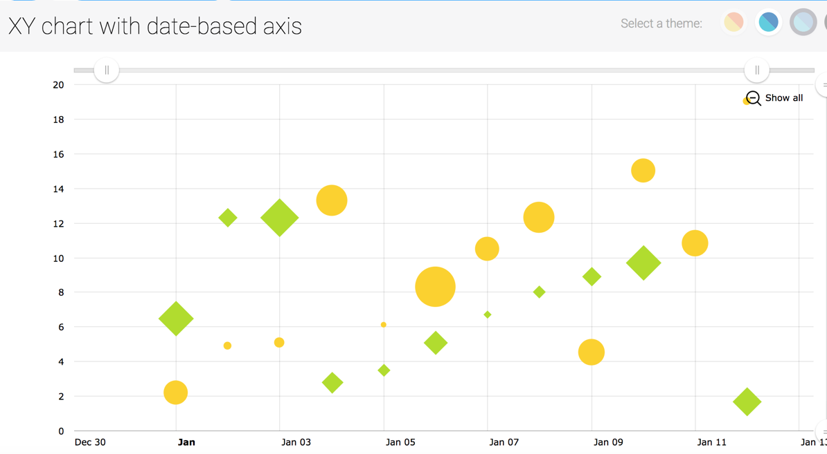

Figure m2. Individual trend bubble chart (https://goo.gl/SNR1B2).

For the third problem, based on the experience of stocks, we combine the k-line with average lines together, such as Moving Average (MA) line. If a user want to operate bitcoin within only three days or shorter, MA5 (Moving Average 5 days) can help him/her to know the recently trend showing like figure m3 below.

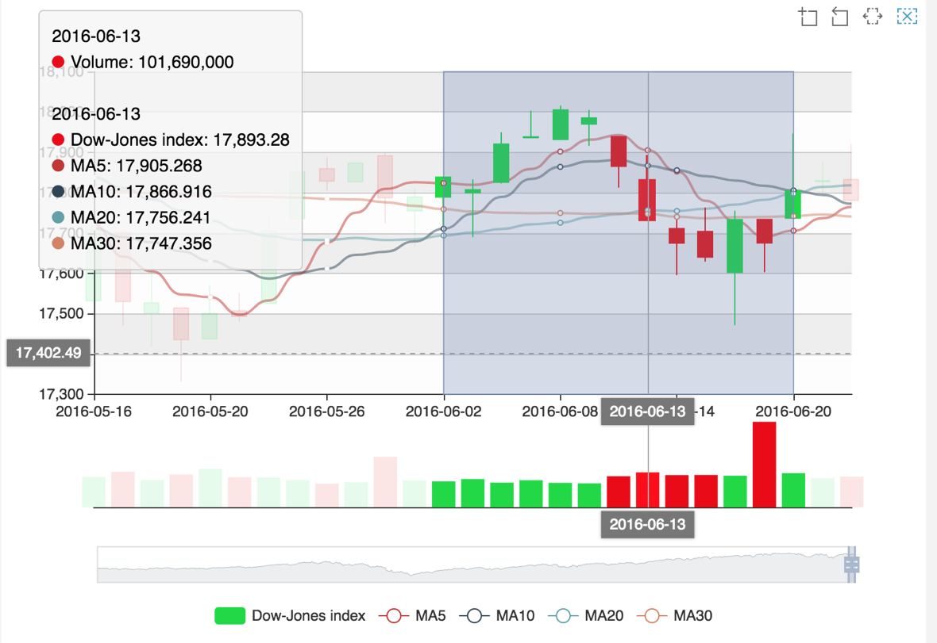

Figure m3. K-line (candlestick chart) https://goo.gl/umik6z.

For the fourth problem, we will also add depth chart in our website, however, we also provide a quantity relative ratio, which has a calculation function “The total number of transactions/ The cumulative opening time is now (minutes)/ Average daily turnover in each minute over the past 5 days” (Function Editing). The depth chart will be shown as below figure m4.

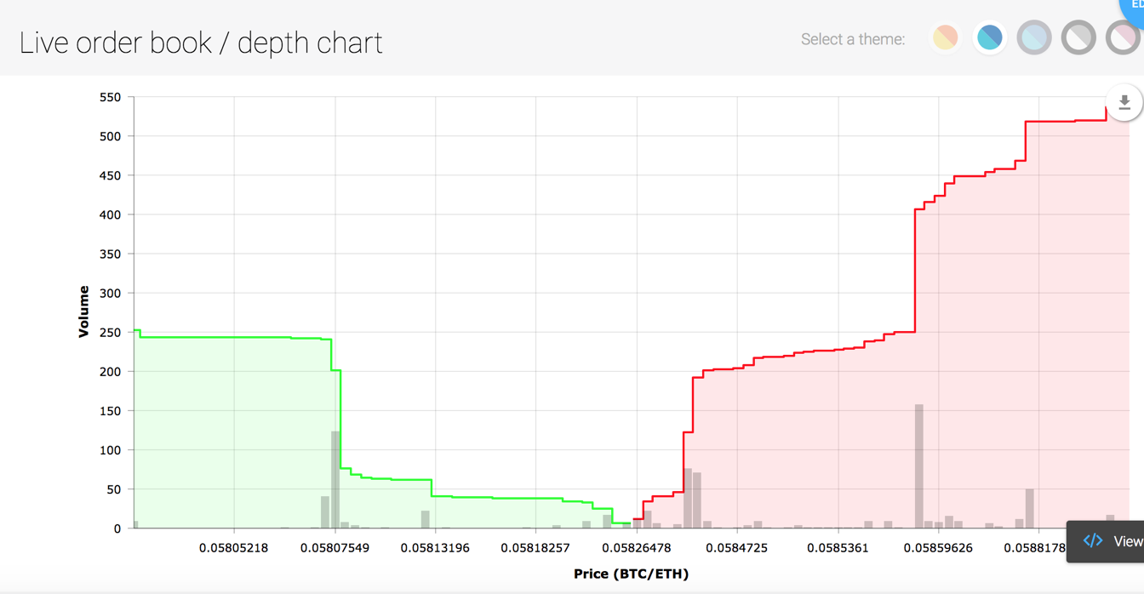

Figure m4. Depth chart. https://goo.gl/nR8ZfL

## Technological

From the technological perspective, according to building an online web-streaming service, we are going to build a web application for bitcoin-exchanges to our customers. After considering about the demands and requirements of this project, the next step is to collect the fundamental information required for the web app development [m4].

### Framework and programming language

The first things we need to confirm are the frameworks and programming languages. We will use MVC framework in our web service, which is good at multi-workers cooperating and easily controlling, furthermore, the details about how we build this framework and what the responsibilities of each block take will be showed in framework section.

Asynchronization means computer multithreading asynchronization processing. Relative to synchronization processing, asynchronization processing doesn’t need to wait current thread finish. It allows the subsequent task start at the same time, until the all other threads complete their task. Then it will use call-back function to announce the current thread.

The node.js used single thread to avoid multithreading, state synchronization problems. Of course, the asynchronization I/O feature can help single thread to avoid block and use CPU in a more efficient way. Of course, the asynchronization will bring some problems, like call-back function nest too deep. But the Promise, Generators and Async function will deal with it.

### Front end and back end

In web application, separated by front-end and back-end, we choose HTML/CSS and Embedded JavaScript (EJS) templates in front-end; Node.js is the best choice for the back-end, which we can use it to build MVC and finish the request/response actions with web browsers. In the front end, we need to draw several charts using amchart.com and echart.com, which are convenient for us to offer many templates using node.js.

In the back-end, we use Application programming interface (API) to get the data from several bitcoin-exchange websites, such as GDAX, Coinbase, Binance and Bitcoin Ticker; and cryptocurrency analytics websites, such as Coinmarket, Coingecko and Fei Xiao Hao. Bitcoin-exchange websites can provide the public data, but the private data can be used in sandbox of GDAX. In the future work, we will contribute much effort into other websites exploration. The bitcoin analytics website is a organization to collect and analyse public data, then give a trend or sort, which can mention users to notice which exchange organization is popular and the size is large. We can use this information to make a better one.

After getting data from outside, we need a database to store data. Based on the format of data using in node JavaScript and MVC framework advantages, we choose MongoDB as our database, which can also save users’ registration and private information, such as, personal information, account details, passphrase, API keys and secrets.

### Basic functions

Finally, some basic functions we will also add in our web service, for instance, automatic edit management, update management, revenue reporting, user tracking and billing management.

# Configuration

## Hardware

The website can be shown in all operate systems and it is compatible with both 32bit and 64bit. We suggest that the Windows OS version should upper than Windows 98 for fluent performance. The RAM is suggested to be larger than 1GB. The Hard Disk is suggested to be larger than 3GB. The video memory of integrated graphics and standalone graphics are suggested to be larger than 1GB. All mobile devices of Android and IOS are compatible.

## Software

### WebStorm:

We use WebStorm as integrated development environment. This IDE will bring us six advantages. First, it can display image attributes when we test the code. Second, it provides automatically reconstitution for label, file name, css file and JavaScript file. Third, build-in SASS, Node.js, Coffee Script and Jade are supported. Fourth, user can customize the template of code. Fifth, the setting item can be searched. Sixth, the WebStorm has a build-in version control.

### MongoDB:

We use MongoDB as database. The MongoDB has six advantages. First, it has Document-oriented feature, that means it doesn’t need strict data structure. Then, High performance and High availability and High usability are there advantage of MongoDB. The Easy scalability brings PB level storage space. Of course, it supports ShardingRich query language. The prefect build-in Java API and supporting Json object are the major advantages of MongoDB.

### Robomongo:

The Robomongo is a GUI of MongoDB, using this software will convince to set and operate the MongoDB.

### Git

By using Git, we will bring us four capabilities of version control. First, the local version warehouse will help us go back to last version in anytime. Second, it is easy to establish branch for multi-user working together. Third, the Git is very fast to switch branch and submit modification that will improve our efficiency. Fourth, the Git can interact with multi-far-end.

### GitKraken

GitKraken is a GUI tool of Git. It convinces for us to operate Git and do the version control.

### Chrome

We using Chrome browser for running, testing and display our website project. Because of the V8 engine, the Chrome is very fast and stable. The Check function of Chrome is an important reason for us, because we can find error and bug in the Chrome console directly, that is convince and efficient for us to run and test the code.

### Slack

Slack is an online community platform, and we use that to discuss the details of the project. The fast file transmission has saved many time for us.

## Framework

### Overview

We used the Express framework which supported by node.js. The Express framework implement the MVC framework. All the data communicate are based on router that provide by Express.

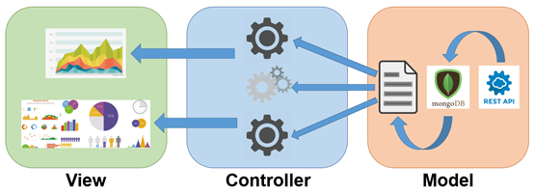

### Model Block

The model block used for acquiring data from exchange website and cryptocurrency exchange platform, like GDAX, Huobi, etc. And reconstitute data from MongoDB. The role of the model block is labor working between controller and data source. The raw data which comes from external data source via Rest API, will be translated into a new structure by many processors or functions in the model block. Then the processed data will be delivered to controller.

### View Block

The view block used for displaying the processed data in a reasonable way which acquired from controller. The data will be shown like, Candle Stick Line, BTC-History Trend line, etc. The role of the view block is a screen of deliverable information. It used css and JavaScript class library to complete the render task. The view block doesn’t need to translate or transform the data, but just show them.

### Controller Block

The controller block used for communicating with model block and view block. The role of controller is a middleware which orders the model block to process expecting raw data, and delivers the processed data to view model for giving the reasonable information.

# Milestones and Reporting

|  |  |  |  |
| --- | --- | --- | --- |
| Milestone | Tasks | Reporting | Date |
| Week-1 | Orientation and team member meeting | Team members meeting to review the project. (State: Good) | 14-03-2018 |
| Week-2 | MVC framework design, and decide to use which develop platform. | Design develop framework, and clear the framework in a hand write draft. (State: Good) | 21-03-2018 |
| Week-3 | Complete the MVC framework, and finish at least one executable work line, like the API’s data can be show in the front end. | Develop framework and finish the draft framework. The executable work line is finished. (State: Good) | 25-03-2018 |
| Week-4 | Create the MongoDB and connect to the database. The data stored in the database should be invoking by frontend.  Finish the proposal draft. | Connect the database and finish at least one completing work line. (State: Good) | 28-03-2018 |
| Week-5 | Proposal Report Due | Finish the proposal report | 13-04-2018 |
| Week-6 | Create a daft frontend, the data can be set in advance. The main page template should be finish. | Create a frontend and finish the main page template. | 13-04-2018 |
| Week-7 | Connect each part of the website, the major function of backend and frontend should be finish. | Finish the draft project and start to optimize it. | 25-04-2018 |
| Week-8 | Testing the draft project, then try to finish all the project. | Test the website performance by many test method | 09-05-2018 |
| Week-9 | Progress Report Due | Finish the progress report | 11-05-2018 |
| Week-10 | Try to deployment the project to some platform. | Try to deploy the website to the internet or the cloud | 16-05-2018 |
| Week-11 | All the documentation should be done. (user manual) | Finish the relative documentation, for example manual. | 23-05-2018 |
| Week-12 | Final Presentation | Prepare and finish finial presentation | 22-06-2018 |
| Week-13 | Final Report (thesis) | Prepare and finish final report | 08-06-2018 |

# Web application deployment

## Web Testing Unit

### 1) Functionality Testing

This unit test will focus on links, button click and scrolling within web pages, database connection between backend and frontend in running state, Cookie testing and so on.

### 2) Usability testing

Usability testing is the process of which the interaction between human and machine. Though this process we can identify the problems and weakness when users, especially those who are not IT technicians, using our web application.

### 3) Compatibility testing

The main components  in compatibility testing consisted of browser compatibility, operating system compatibility, mobile browsing, printing options.

### 4) Performance testing

Web performance testing should include: Web Load Testing and Web Stress Testing. Test application performance on different internet connection speed.

### 5) Security testing

The potential vulnerabilities in a web application includes: network Scanning, vulnerability scanning, password cracking, log review, integrity checkers, virus detection.

# Reference

[m4] Web Applications Development Methodology - Pillars of strength, IT Outsourcing India, viewed 28 Mar 2018, http://www.itoutsourcingindia.com/about/web

m1: https://goo.gl/SNR1B2

m2:<https://goo.gl/umik6z>

m3: https://goo.gl/nR8ZfL

Image:

58pic.com. (2018). *File example image*. [online] Available at: http://www.58pic.com/shiliangtu/13953918.html [Accessed 1 Apr. 2018].

Kor.pngtree.com. (2018). *Chart image example*. [online] Available at: https://kor.pngtree.com/freepng/fashion-business-information-graphic-design-vector-material-_1915625.html [Accessed 1 Apr. 2018].

Pptfans.cn. (2018). *Line chart example*. [online] Available at: http://www.pptfans.cn/pptmuban/tubiao/zhexiantu [Accessed 1 Apr. 2018].